Administrator Guide

jWebSocket
SMS Gateway
Mayra Eva Marañón Rodriguez

Version history?

1. Process application download
For the installation of this application should be downloading the packages containing the jWebSocket client and server. The URL where the application is available for download is http://jwebsocket.org/downloads .
Packages | Size
SMS Server | 111,1 Kb
jCaptcha Server | 96,3 Kb
SMSGateway Client | 241,3 Kb

2. Installation process
Tto install the application on the Linux operating system the SMSGateway client package containing the application client must be copied var/www. Tto do this you need to install Apache. In addition it should be given all permits through the console. The server package can be stored in any location. Before running the client browser must be set to run the server on an IDE. Don‘t underdstand this sentence, do you mean „Before you can run the client you need to start the server”. Please explain how to start the server. This is a single line, so that nobody needs to lookup in other documents.
If the operating system is Windows should have installed the Wamp application that creates the folder C:\\wamp\www, this is the target to copy the package containing the client. The package containing the server can be stored in any location. Before running the client browser must be set to run the server on an IDE. This sentence is redudant! See above.
5. Operation
To run the application should start the server and then open jWebSocket client SMSGateway in any of the browsers supported by WebSocket.
How to start? See above.

6. SMSGateway Configuration
The jCaptcha plugin and SMS plugin settings can be managed in rte/jWebSocket-1.0/conf/jWebSocket.xml, where you can also configure other plugins. Below are the plugins configurations for jWebSocket:
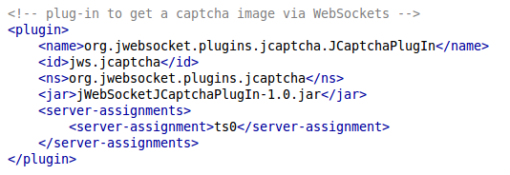
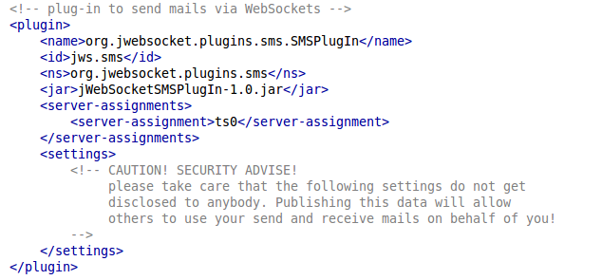 I think this listig misses the reference to spring configuration, please check and complete!
Please also give information about the spring configuration!

<?xml version="1.0" encoding="UTF-8"?>
<beans xmlns="http://www.springframework.org/schema/beans"
xmlns:xsi="http://www.w3.org/2001/XMLSchema-instance"
xsi:schemaLocation="http://www.springframework.org/schema/beans http://www.springframework.org/schema/beans/spring-beans-2.0.xsd">

<!-- CAUTION! SECURITY ADVISE!
please take care that the following settings do not get
disclosed to anybody. Publishing this data will allow
others to use your SMS account on behalf of you which may
lead to spam attacks and costs!
-->

<!-- this is the configuration for the provider "SMSTrade" -->
<bean id="providerSmstrade" class="org.jwebsocket.plugins.sms.ProviderSmstrade">
<property name="key" value="#your key at SMSTrade#"/>
</bean>

<!-- here you configure which SMS provider of the above ones to use in the SMS plug-in -->
<bean id="org.jwebsocket.plugins.sms.settings" class="org.jwebsocket.plugins.sms.Settings">
<property name="provider" ref="providerSmstrade"/>
</bean>

</beans>
7. Application Management
To administer SMSGateway can be supported in the user manual.
In the event of any problems during installation of the application, contact:
Mayra Eva Marañón Rodriguez
Mail: memaranon@hab.uci.cu

